

Project 2

Smart Weather Project



A SIMPLILEARN PROJECT

FOR AGILE SCRUM MASTER COURSE

**SUBMITTED BY: Shubham Saxena**

**List of Project Tasks**

* Identify at least five epics and 15 user stories from the case above(use your interpretation and independent research). Link the stories to the epics.
* Get a free JIRA account and create a Scrum project.
* Enter the backlog (epics, stories and sub-tasks) in JIRA.
* Make a tentative release plan, by assigning the stories to three sprints.
* Start and complete one sprint.
* Submit screenshots of: Epics, Backlog,release plan, and Scrum board with tasks in various states.

**PROJECT CREATION**

SMART WEATHER PROJECT

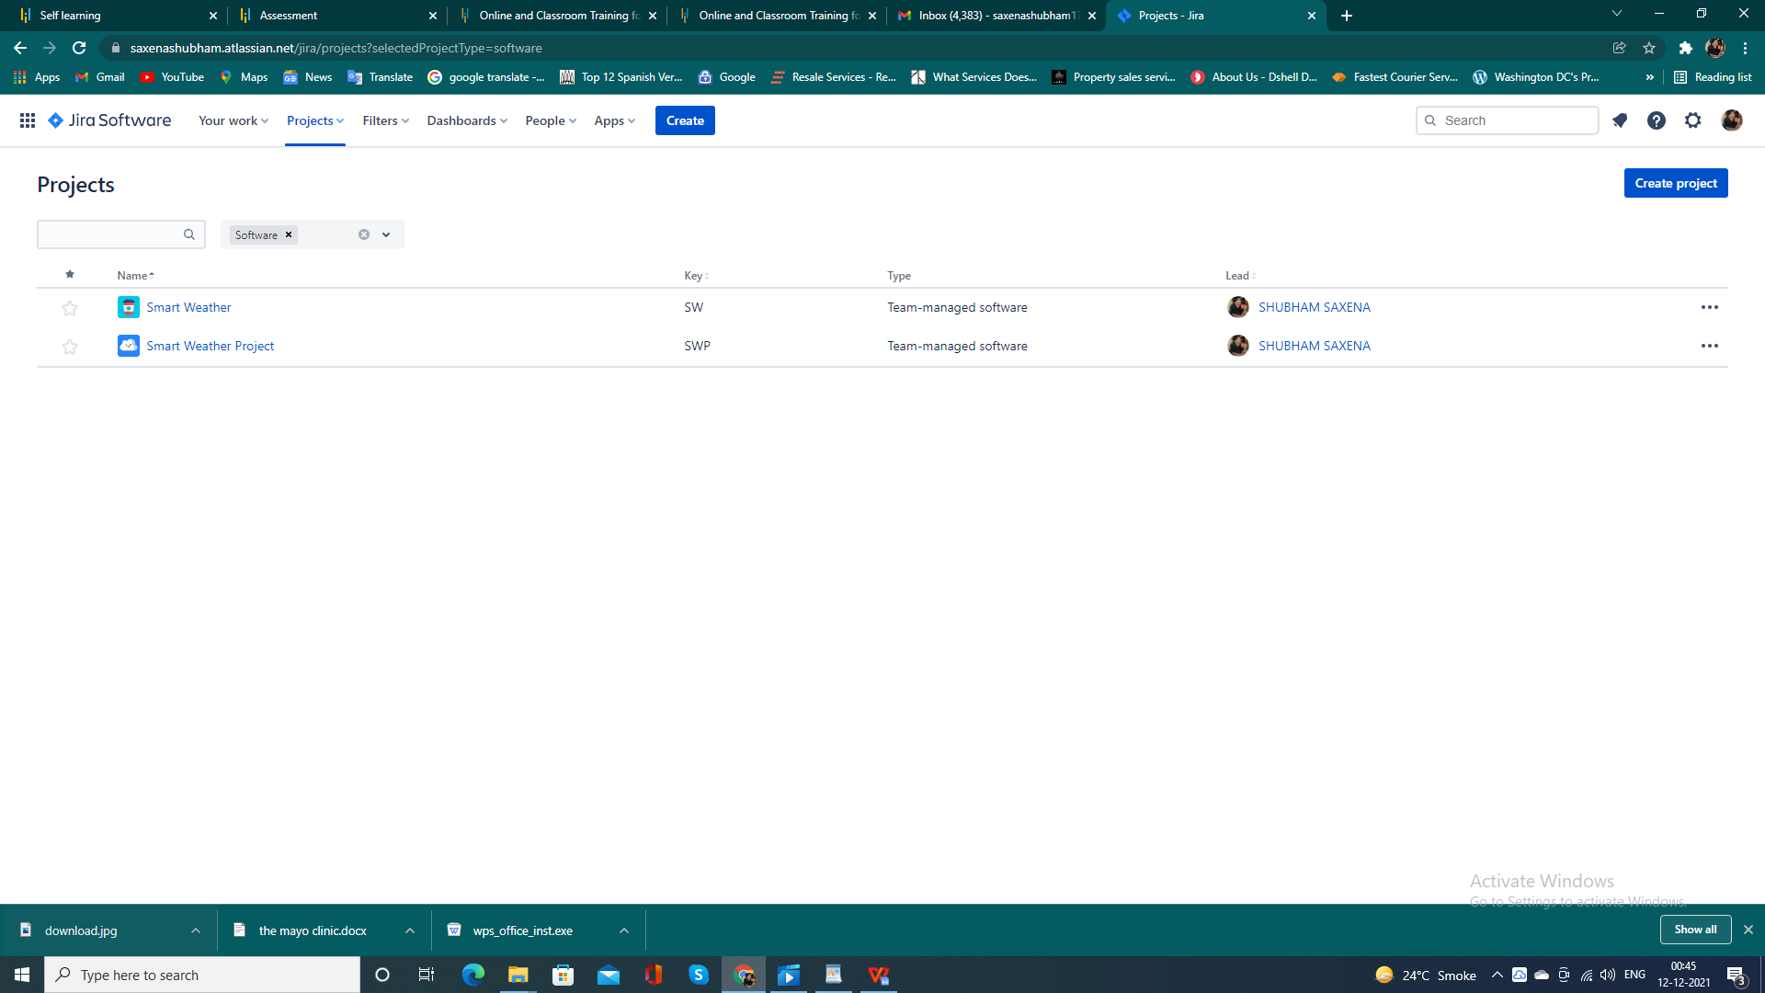

**EPIC CREATION**

1. Location
2. Satellite
3. Device
4. User portal
5. Features

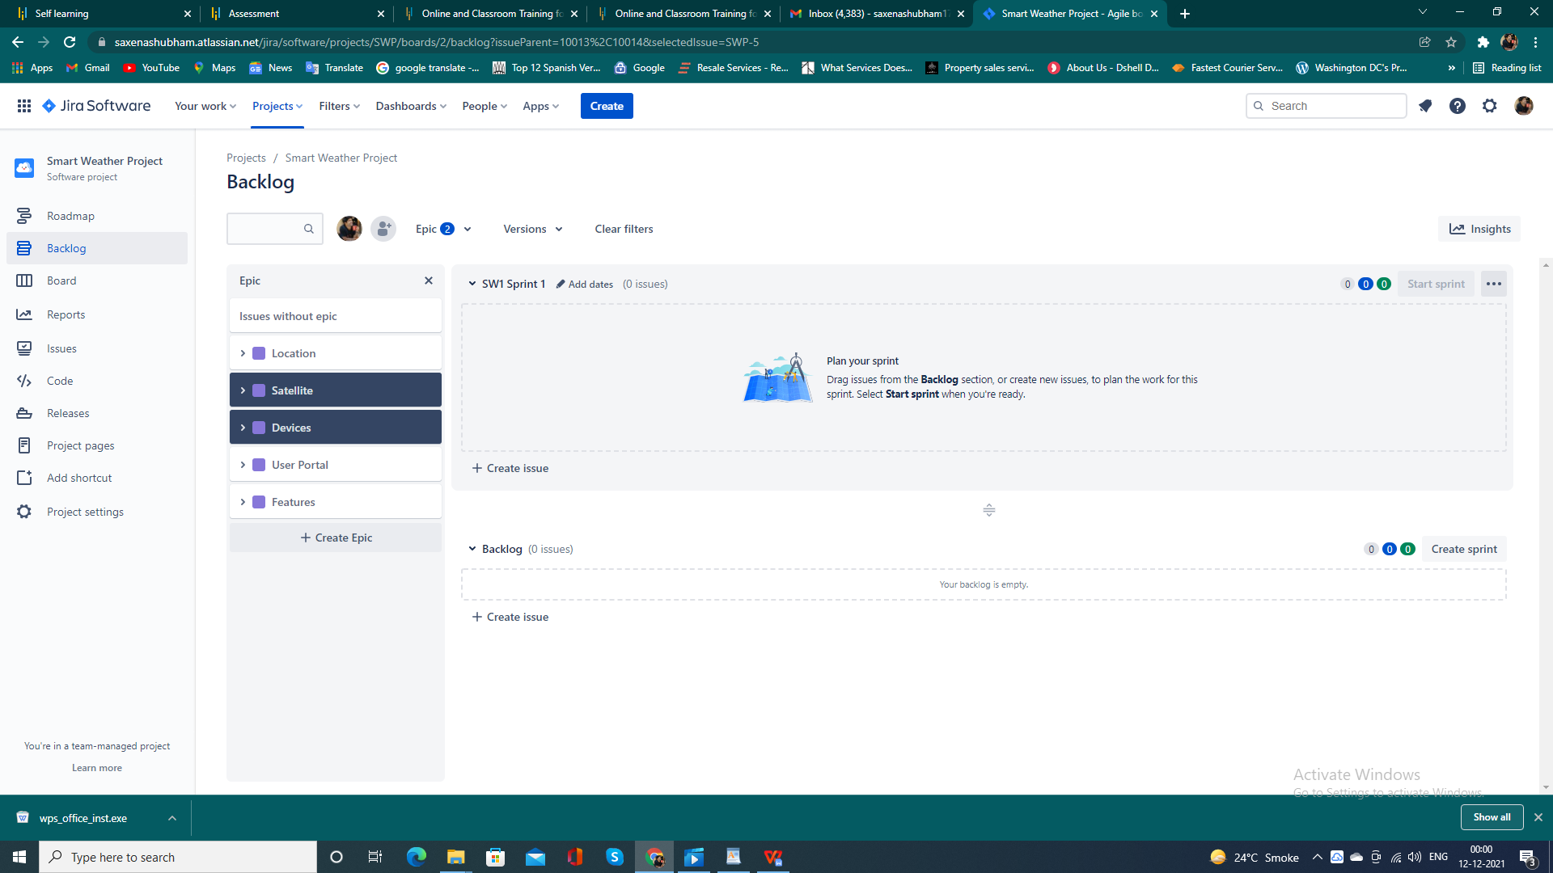

**STORY CREATION, PRIORITY ASSIGN,**

**STORY POINTS**

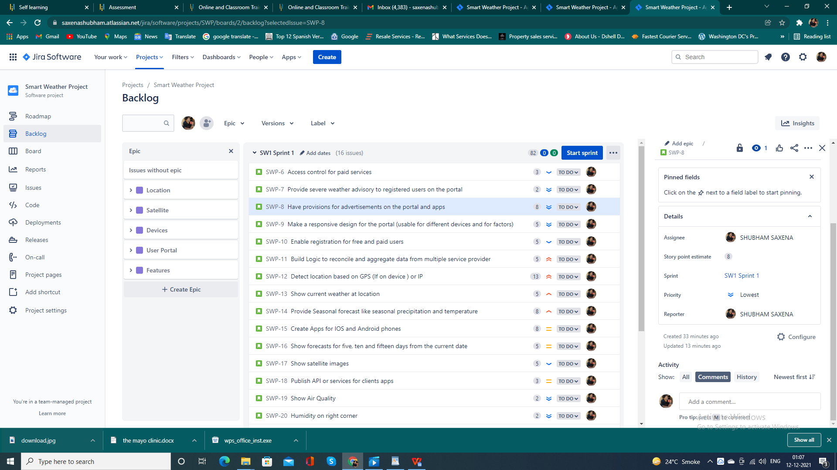

**STORY TO EPICS**

1. LOCATION

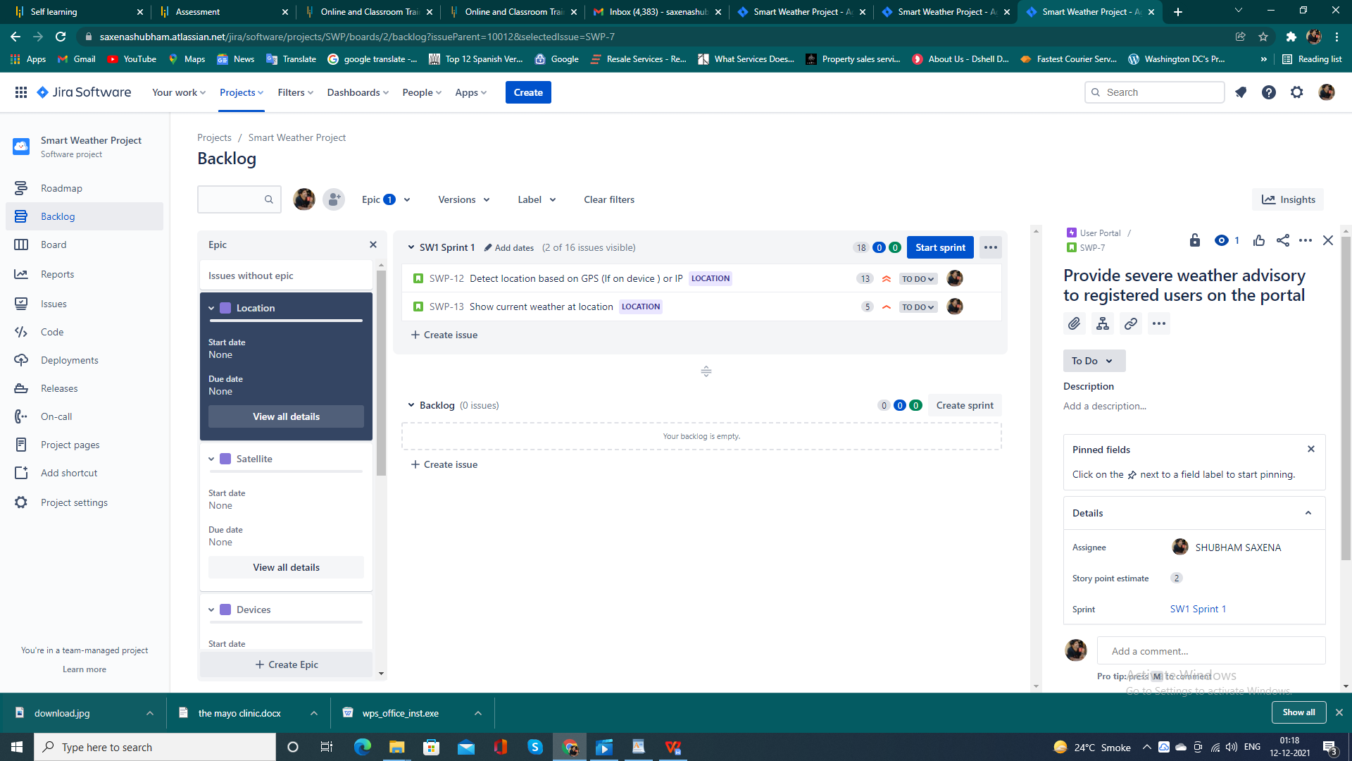

1. SATELLITE

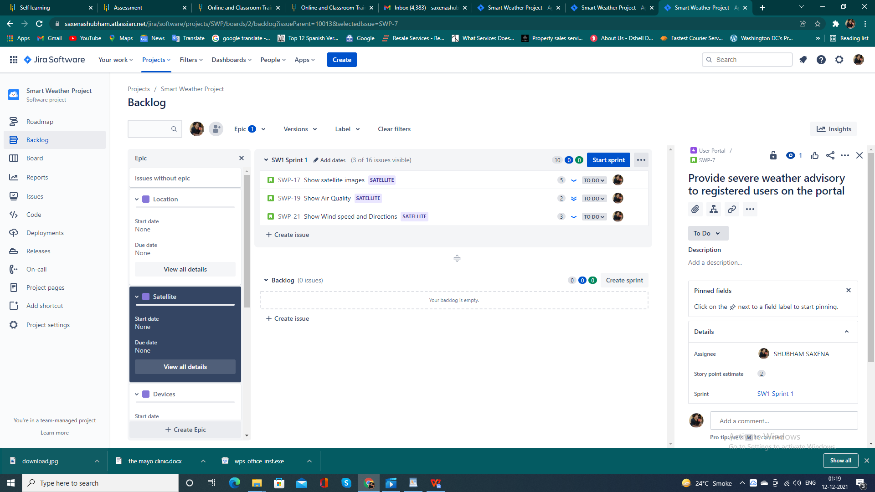

1. DEVICES

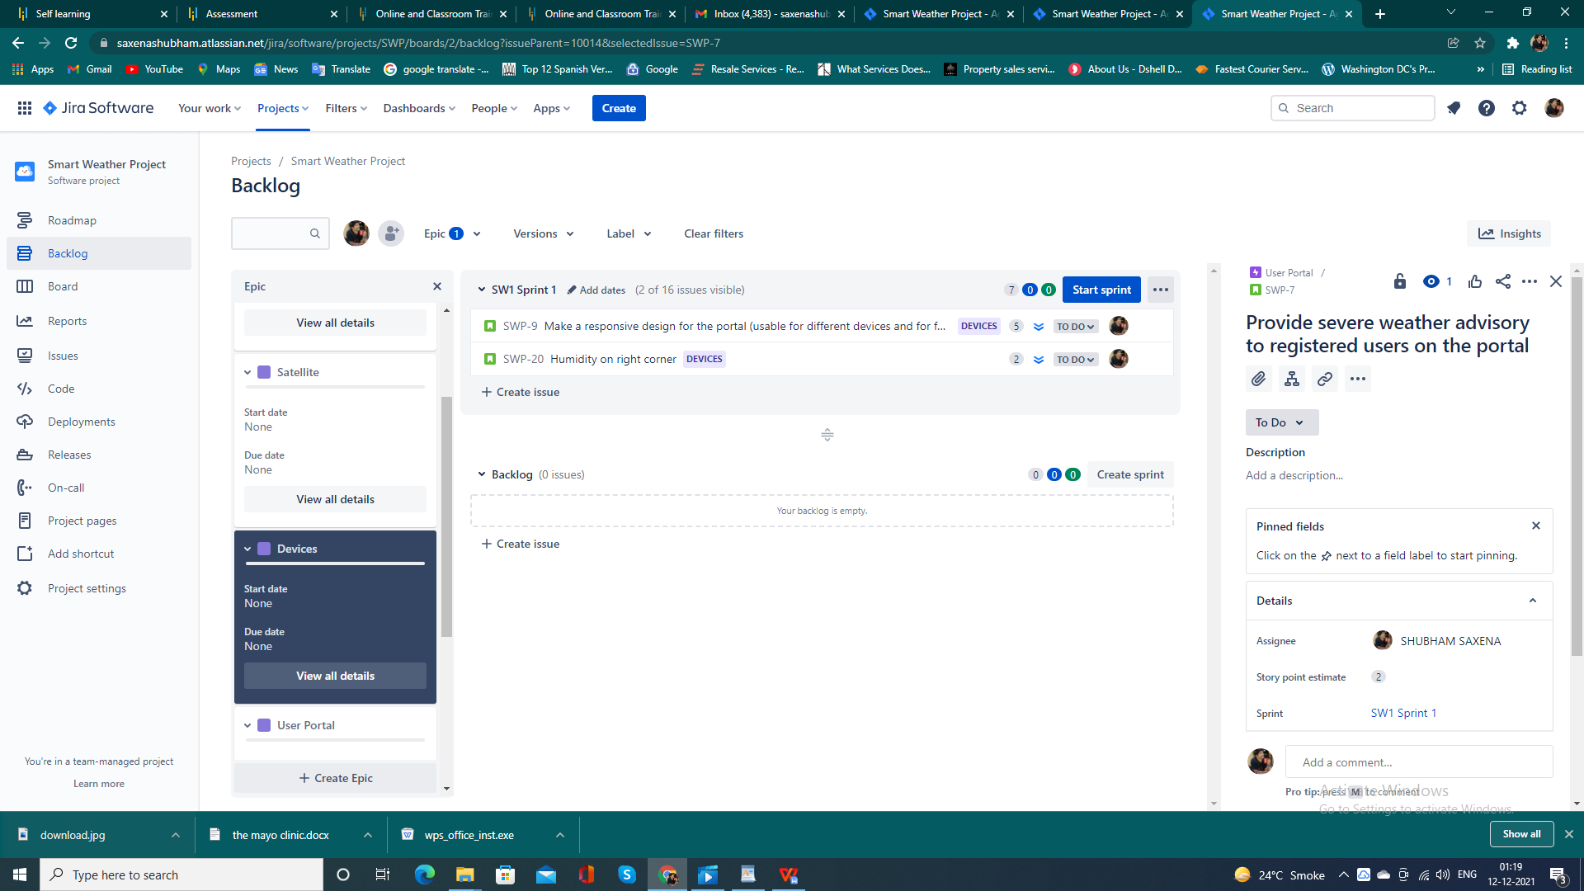

1. USER PROTAL

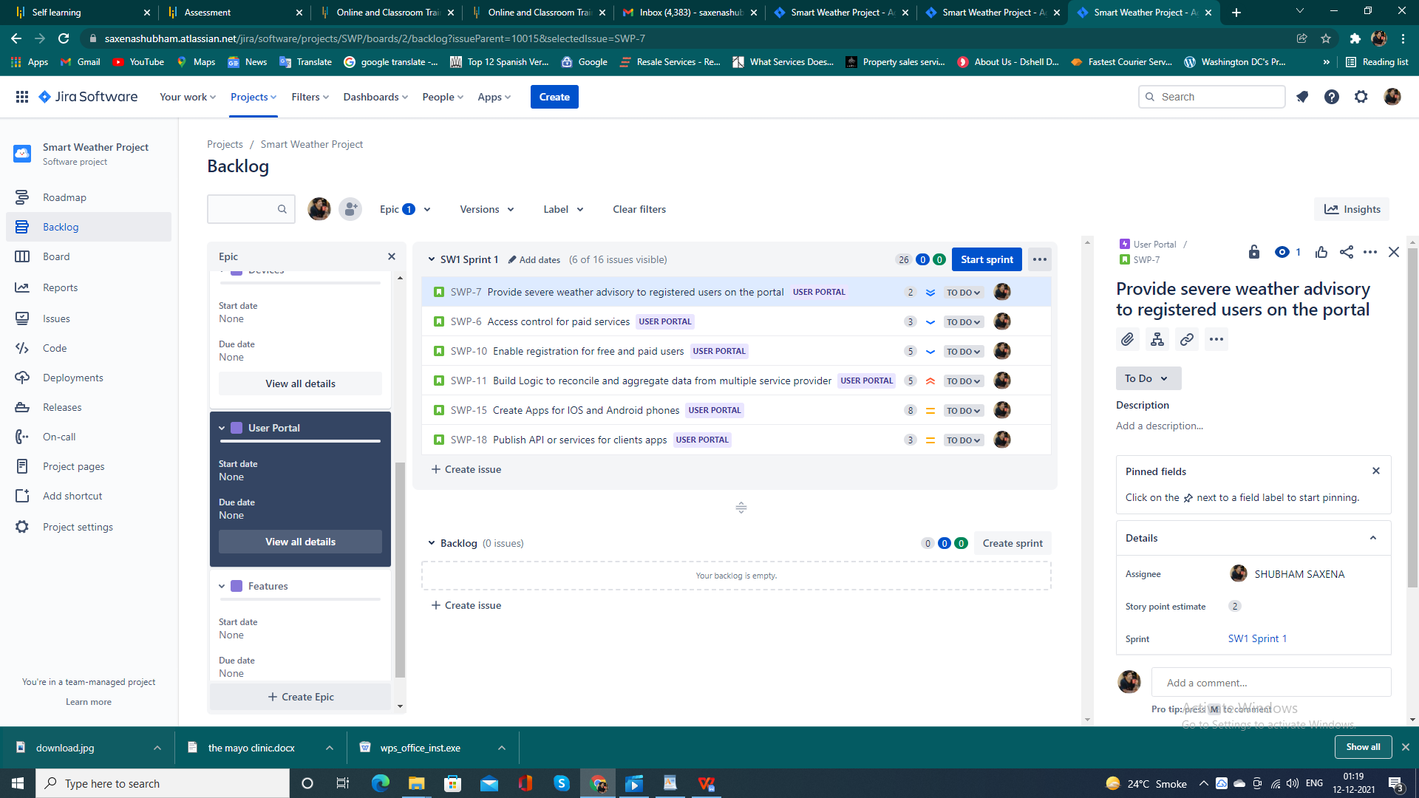

1. FEATURES

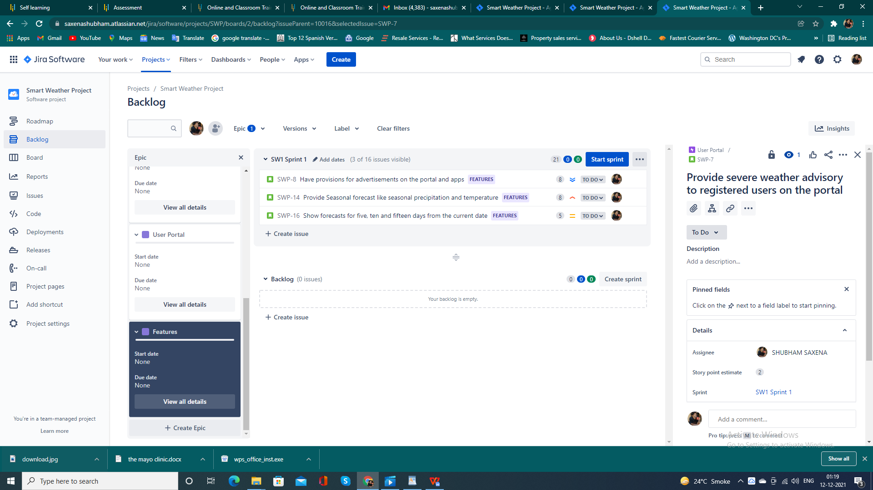

**SPRINT FORMATION OR START OF SPRINT 1**

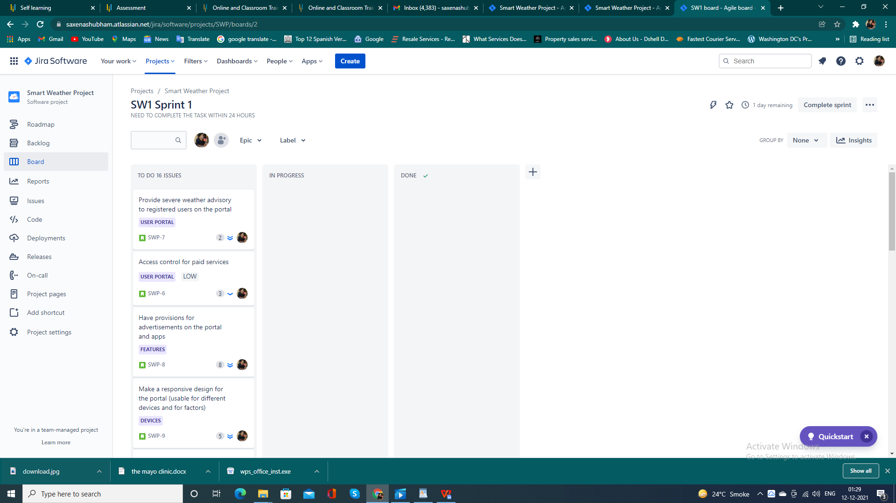

**HIGHER PRIORITY SPRINT IN PROGRESS**

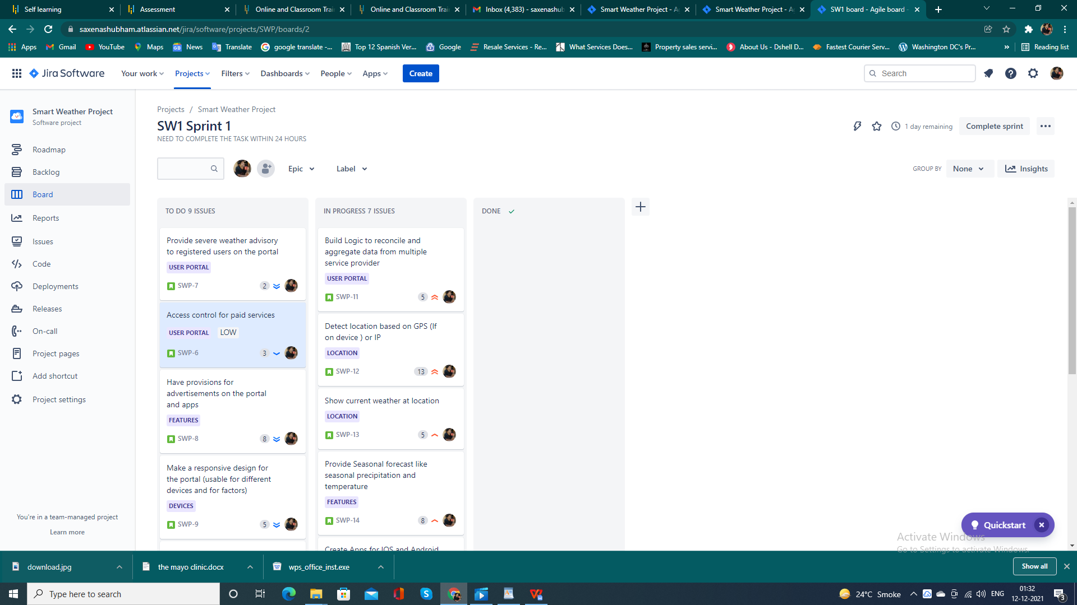

**LAST DAY REMAINING**



**SPRINT COMPLETION**

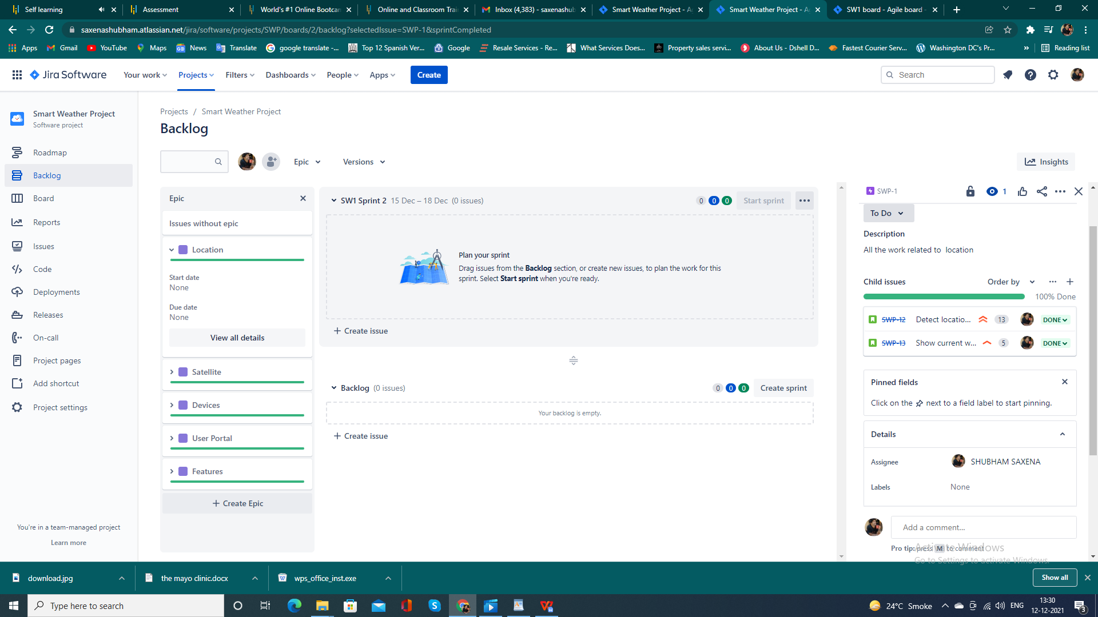

**BURNUP REPORT**

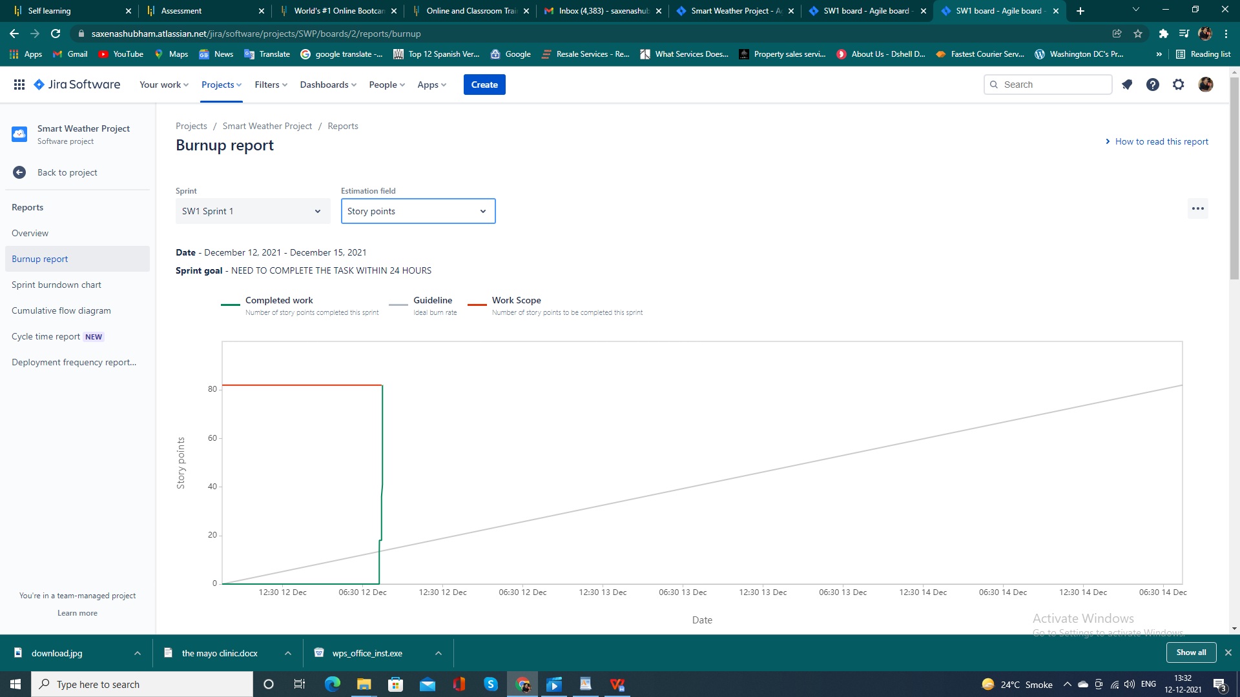

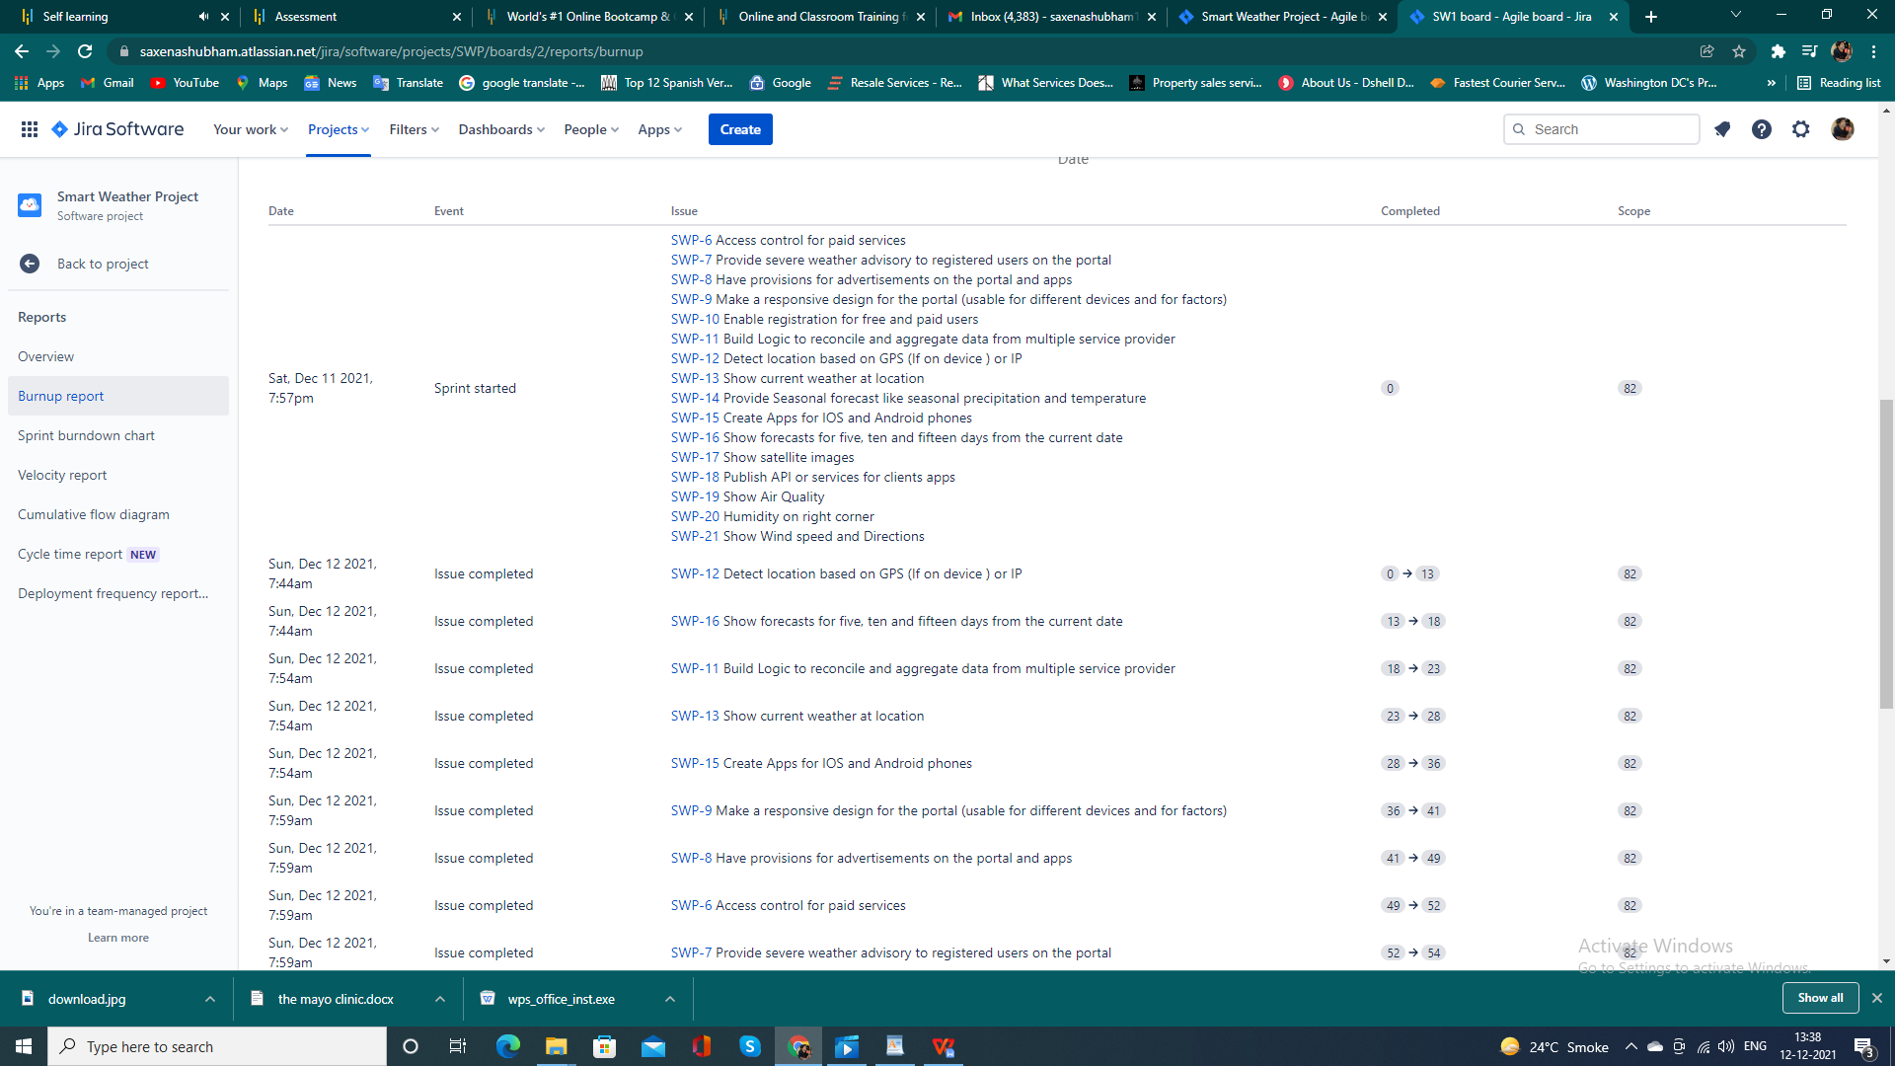

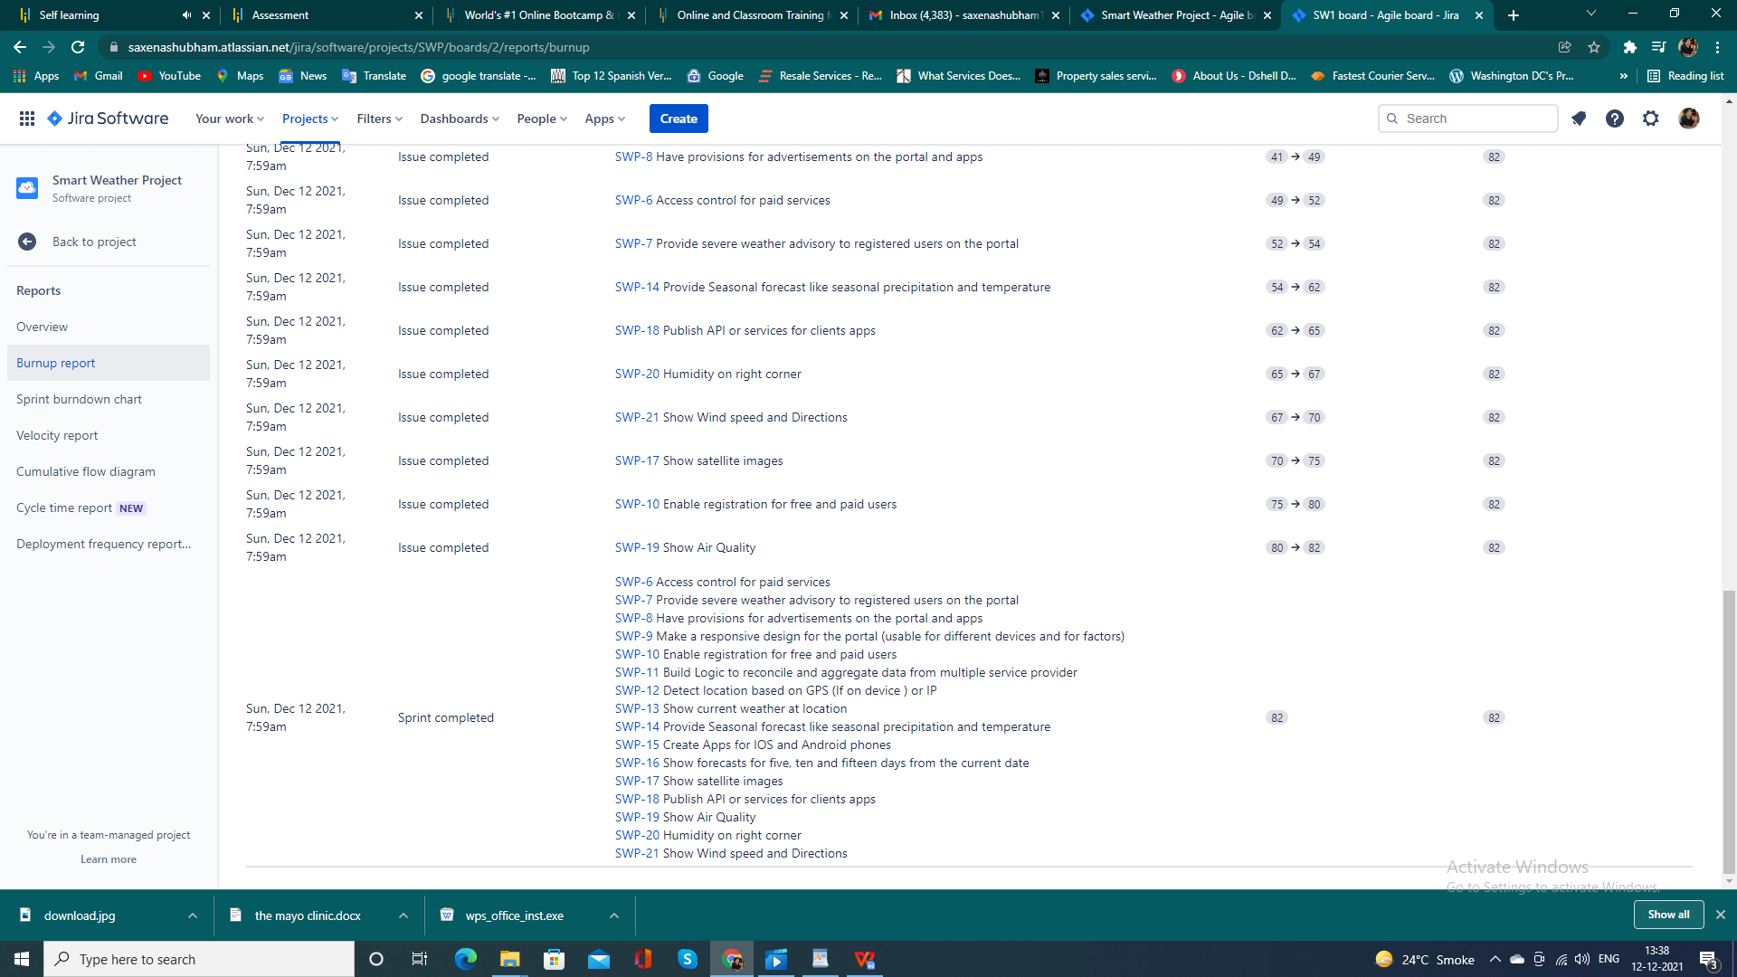

**BURNDOWN REPORT**

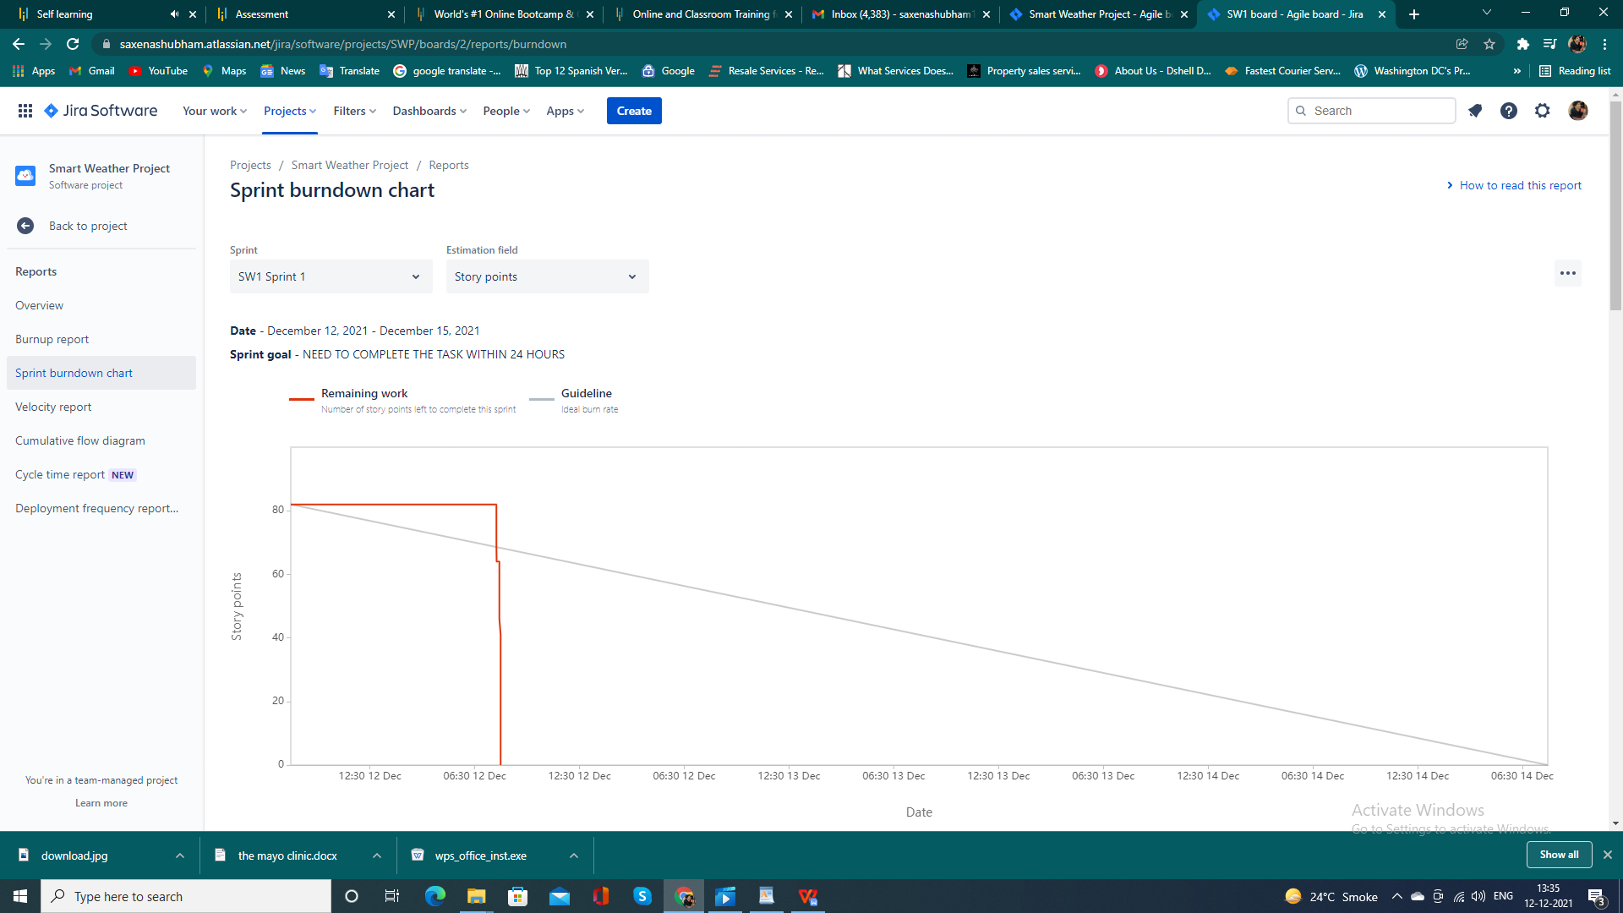

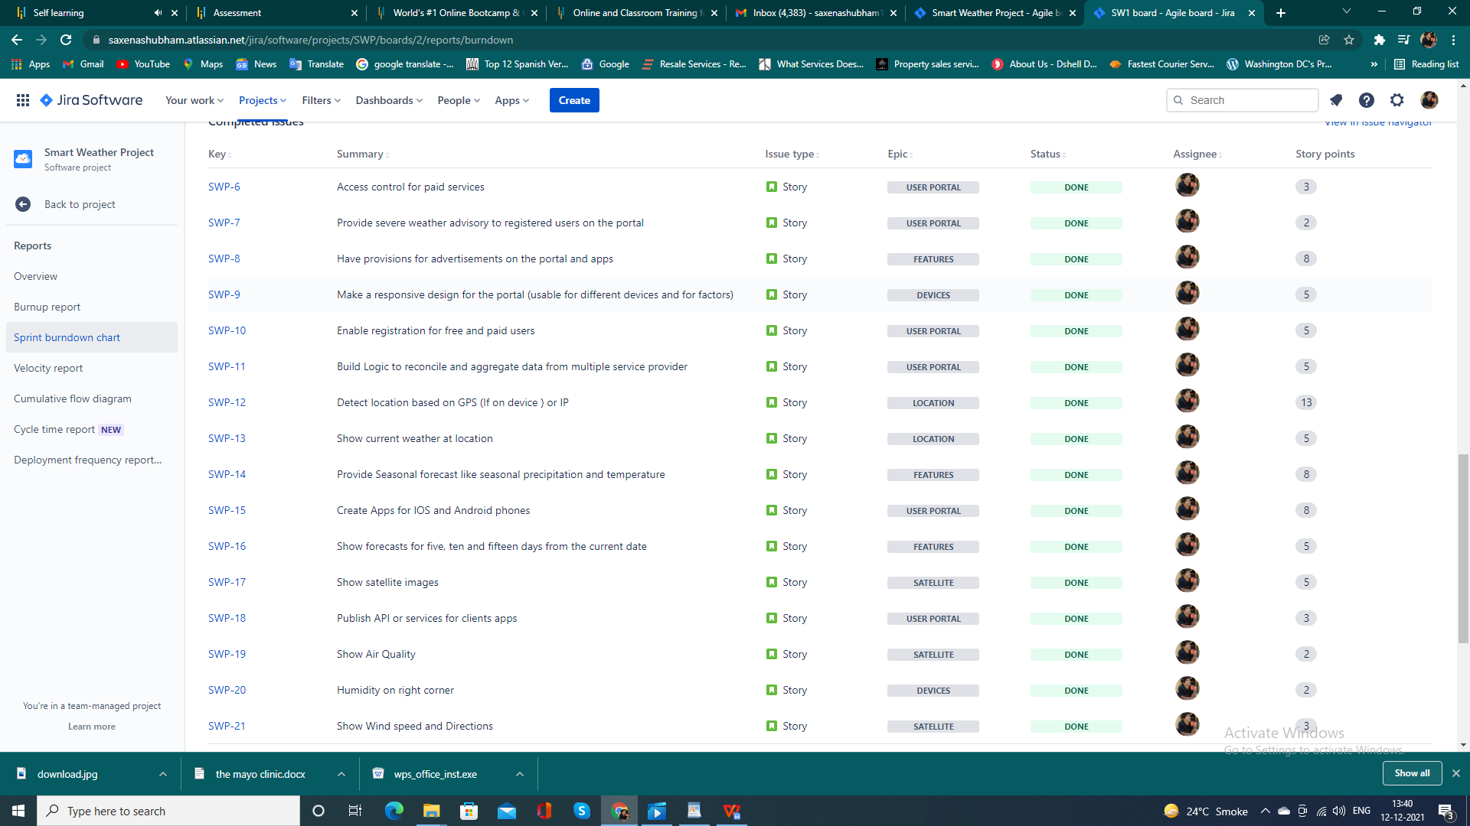

**VELOCITY REPORT**

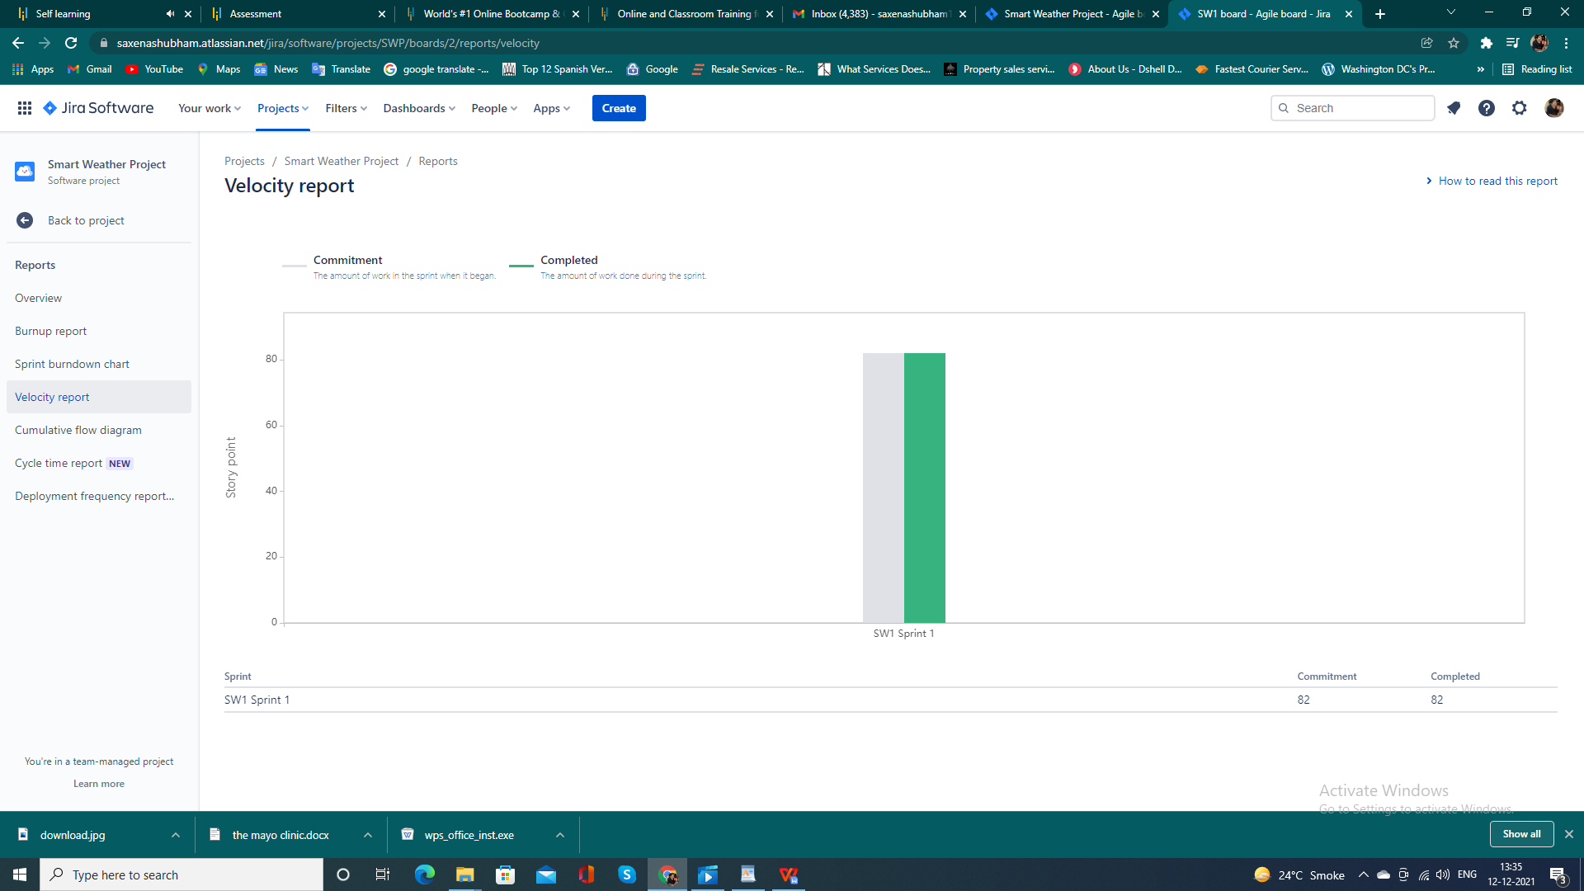

**CUMULATIVE FLOW DIAGRAM**

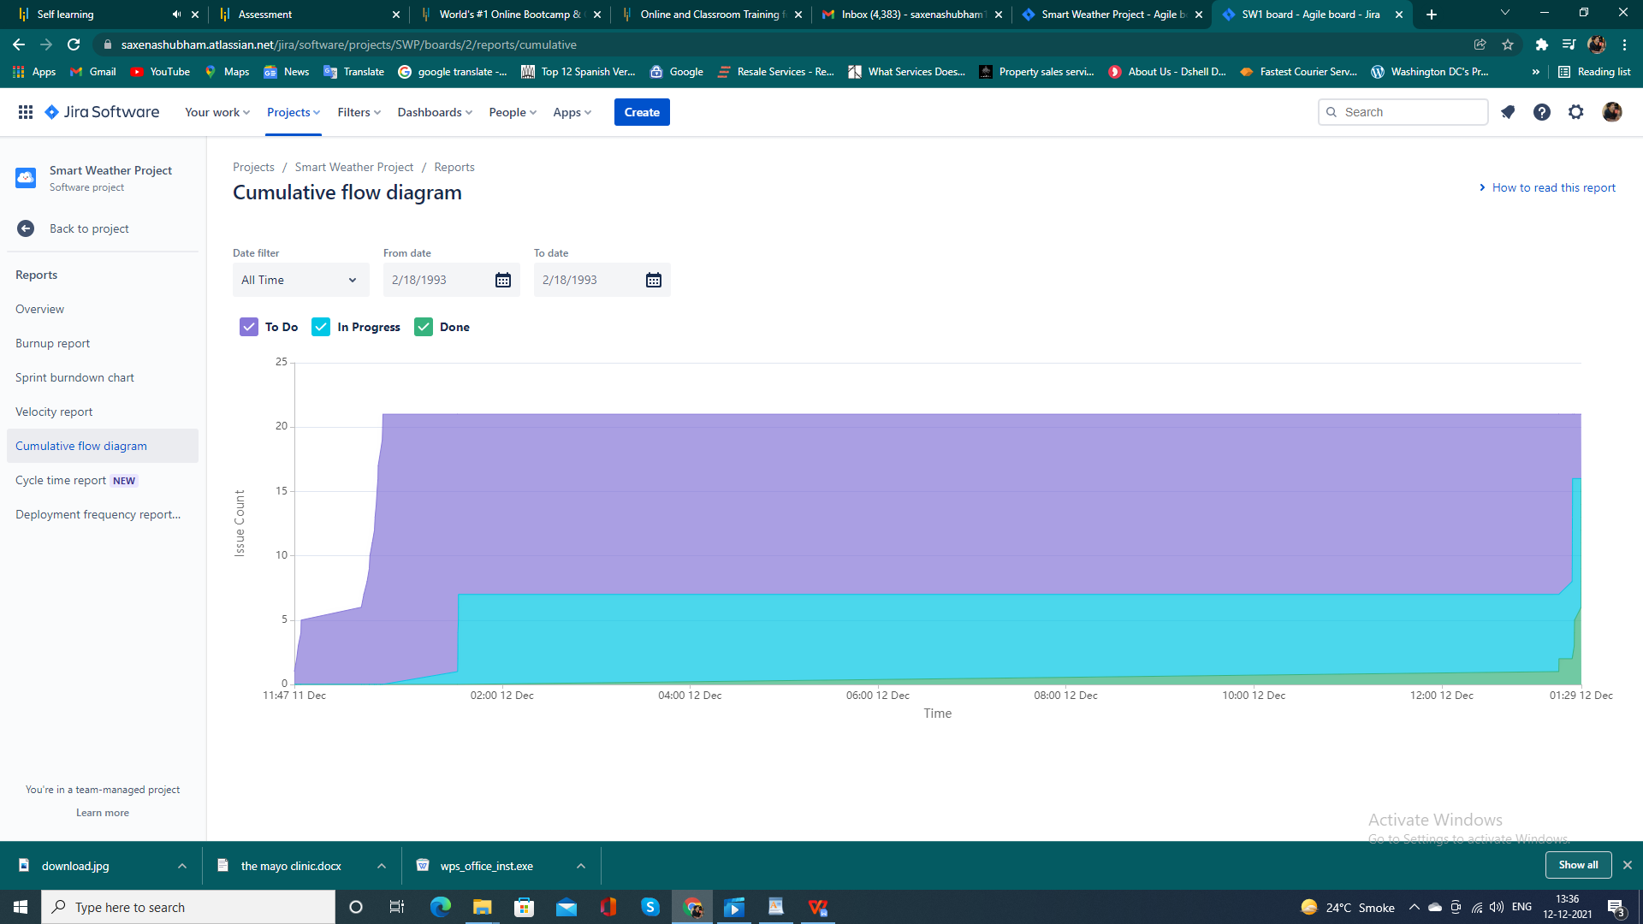

**THANK YOU**